A MINI PROJECT REPORT ON

STUDENT GRADES PREDICTION USING MACHINE LEARNING USING FLASK
Submitted by,

N.DEEKSHITH KUMAR | 23J41A3345
P.RAVINDAR NAYAK | 23J41A3348
P.DOLESHWAR | 24J45A3305
J.GURUNATH  M.AAKASH | 23J41A3328  23J41A3301
In partial fulfillment of the requirements for the award of the degree
of

BACHELOR OF TECHNOLOGY
In

COMPUTER SCIENCE AND INFORMATION TECHNOLOGY

UndertheGuidanceof

Mr.M. RAVINDRA BABU
AssistantProfessor, Information Technology


COMPUTER SCIENCE AND INFORMATION TECHNOLOGY

MALLAREDDY ENGINEERING COLLEGE
(An UGC Autonomous Institution, Approved by AICTE, NewDelhi & Affiliated to JNTUH, Hyderabad)
Maisammaguda, Secunderabad, Telangana, India 500100
MAY-2026

MALLA REDDY ENGINEERING COLLEGE
Maisammaguda,Secunderabad,Telangana,India500100


BONAFIDE CERTIFICATE

This is to certify that this major project work entitled “STUDENT GRADES PREDICTION USING MACHINE LEARNING USING FLASK”, submitted by N.DEEKSHITH KUMAR(23J41A3345) , P.RAVINDAR NAYAK(23J41A3348) ,P.DOLESHWAR(24J45A3305),J.GURUNATH(23J41A3328),M.AAKASH(23J41A3301)Malla Reddy Engineering College affiliated to JNTUH, Hyderabad in partial fulfillment for the award of Bachelorof Technology in COMPUTER SCIENCEAND INFORMATION TECHNOLOGYis a bonafide record of project work carried out under our supervision during the academic year 2025 – 2026 and that this work has not been submitted elsewhere for a degree.

SIGNATURE  Mr.M.RAVINDRABABU  AssistantProfessor,  Information Technology  Malla Reddy Engineering College  Secunderabad, 500 100 | SIGNATURE  Dr.DEENABABU MANDRU  HOD  Information Technology  Malla Reddy Engineering College Secunderabad, 500 100

Submitted forMiniProject viva-voce examination held on

INTERNALEXAMINER EXTERNALEXAMINER

MALLA REDDY ENGINEERING COLLEGE
Maisammaguda, Secunderabad, Telangana, India 500100

DECLARATION
I hereby declare that the project titled “STUDENT GRADES PREDICTION USING MACHINE LEARNING USING FLASK”, submitted to Malla Reddy Engineering College (Autonomous) and affiliated with JNTUH, Hyderabad, in partial fulfillment of the requirements for the award of a Bachelor of Technology in COMPUTER SCIENCEAND INFORMATION TECHNOLOGY, represents my ideas in my own words. Wherever other’s ideas or words have been included, I have adequately cited and referenced the original sources. I also declare that I have adhered to all principles of academic honesty and integrity, and I have not misrepresented, fabricated, or falsified any idea, data, fact, or source in my submission. I understand that any violation of the above will because for disciplinary action by the Institute. It is further declared that the project report or any part thereof has not been previously submitted to any University or Institute for the award of degree.
 |  | Signature(s)
N.DEEKSHITH KUMAR | 23J41A3345
P.RAVINDAR NAYAK | 23J41A3348
P.DOLESHWAR | 24J45A3305
J.GURUNATH | 23J41A3328
M.AAKASH | 23J41A3301

Secunderabad-500100
Date:

MALLA REDDY ENGINEERING COLLEGE
Maisammaguda,Secunderabad, Telangana,India500100

ACKNOWLEDGEMENT

We would like to express our sincere thanks to Dr.P. RAVINDER REDDY ,professor, Principal, MREC(A) for providing the working facilities in the college.Our sincere thanks and gratitude to Dr.DEENA BABU MANDRU Professor & Head, Department of COMPUTER SCIENCE AND INFORMATION TECHNOLOGY MREC(A) for all the timely support and valuable suggestions during the period of our project.We are thankful to our Project Coordinator Ms.M.Anusha, Assistant Professor, Department of Computer Science and Information Technology, for his cooperation during the project work.
We are greatly thankful and indebted to our internal guide, Mr.M.RAVINDRA BABU, Assistant Professor, Department of IT,MREC(A)for his constant guidance, encouragement and moral support throughout the project.
Finally, we would also like to thank all the faculty and staff of the IT Department who helped us directly or indirectly, parents and friends for their cooperation in completing the project work.

N.DEEKSHITH KUMAR  P.RAVINDAR NAYAK  P.DOLESHWAR  J.GURUNATH  M.AAKASH | 23J41A3345  23J41A3348  24J45A3305  23J41A3328  23J41A3301
ABSTRACT

Predicting student academic performance has become an important application of machine learning in the education domain. This project presents a web-based system that predicts student grades using machine learning algorithms and deploys the model through the Flask framework. The objective of this system is to assist educators and institutions in identifying students at risk and enabling timely interventions to improve academic outcomes.
The system makes use of historical student data such as attendance, study hours, previous academic performance, socio-economic background, and participation in extracurricular activities. The collected data is preprocessed and used to train machine learning models such as Linear Regression, Decision Trees, and Random Forest. These models analyze patterns in the data to generate accurate predictions of student grades.
The trained model is integrated into a Flask-based web application, providing a user-friendly interface where users can input student details and obtain predicted grades in real time. This approach combines machine learning with web development to create an interactive and practical educational tool.
Overall, the proposed system demonstrates how data-driven techniques can enhance decision-making in education, support personalized learning, and help institutions improve student success rates.

KEY WORDS:

- Student Performance Prediction
- Machine Learning
- Flask
- Educational Data Mining
- Predictive Analytics
- Web Application
- Data Preprocessing
- Academic Performance Analysis

TABLE OF CONTENTS

CERTIFICATE | I
DECLARATION | II
ACKNOWLEDGEMENT | III
ABSTRACT | IV
TABLE OF CONTENTS | V
TABLE OF CONTENTS | VI
TABLE OF CONTENTS | VII

CHAPTER | DESCRIPTION | PAGE NO.
1 | INTRODUCTION | 1
1.1 | INTRODUCTION | 1
2 | LITERATURE SURVEY | 3
2.1 | LITERATURE SURVEY | 3
3 | EXISTING SYSTEM | 4
3.1 | EXISTING SYSTEM | 4
3.2 | DISADVANTAGES | 5
3.3 | PROPOSED SYSTEM | 6
3.4 | ADVANTAGES | 6
4 | SYSTEM REQUIREMENTS | 7
4.1 | SYSTEM REQUIREMENTS | 7
4.1.1 | H/W SYSTEM CONFIGURATION | 7
4.2 | SOFTWARE REQUIREMENTS | 7
5 | SYSTEM ARCHITECTURE | 8
5.1 | SYSTEM ARCHITECTURE | 8
6 | SYSTEM STUDY | 9
6.1 | SYSTEM STUDY | 9
6.1.1 | FEASIBILITY STUDY | 10
6.1.1.a | ECONOMICAL FEASIBILITY | 10
6.1.1.b | TECHNICAL FEASIBILITY | 10
6.1.1.c | OPERATIONAL FEASIBILITY | 10
7 | SYSTEM DESIGN | 11
7.1 | SYSTEM DESIGN | 12
7.1.1 | UML DIAGRAMS | 13
7.1.2 | CLASS DIAGRAM | 14
7.1.3 | SEQUENCE DIAGRAM | 15
7.1.4 | ACTIVITY DIAGRAM | 16
7.1.5 | DATA FLOW DIAGRAM | 17
7.1.6 | COMPONENT DIAGRAM | 18
7.1.7 | USE CASE DIAGRAM | 18
7.1.8 | DEPLOYMENT DIAGRAM | 19
7.1.9 | ARCHITECTURE BLOCK DIAGRAM | 19
7.2 | SOFTWARE ENVIRONMENT | 20
7.3 | HISTORY OF PYTHON | 20
7.4 | MODULE DESCRIPTION | 26
8 | IMPLEMENTATION AND METHODOLOGY | 22
8.1 | MODULE DESCRIPTION | 23
8.3 | ALGORITHMIC IMPLEMENTATION | 25
8.4 | SYSTEM EXECUTION FLOW
9 | SYSTEM TEST | 26
9.1 | SYSTEM TEST | 27
9.2 | TYPES OF TESTS | 28
10 | RESULTS AND DISCUSSIONS | 29
10.1 | FINAL OUTPUT AND SCREENSHOTS | 30
10.2 | PERFORMANCE METRICS | 32
10.3 | COMPARATIVE ANALYSIS OF ALGORITHMS | 33
10.4  10.5 | DISCUSSION OF RESULTS  LIMITATIONS OF CURRNET SYSTEM | 34  34
11 | CONSLUSION AND FUTURE SCOPE | 35
11.1 | CONCLUSION | 35
11.2 | FUTURE SCOPE | 36-38
12 | REFERENCES | 39-40

CHAPTER-1
1.1 INTRODUCTION
In recent years, the integration of technology in education has led to the generation of large volumes of student data. Analyzing this data effectively can provide valuable insights into student learning patterns and academic performance. One of the most promising approaches for such analysis is machine learning, which enables systems to learn from historical data and make predictions about future outcomes. In the context of education, predicting student grades can help institutions identify weak learners at an early stage and take appropriate measures to improve their performance.

Student performance is influenced by multiple factors, including attendance, study habits, previous academic records, socio-economic background, and participation in extracurricular activities. Traditional methods of evaluating student performance often rely on manual analysis, which can be time-consuming and less accurate. Machine learning models such as Linear Regression, Decision Trees, and Random Forest provide a more efficient and reliable way to analyze these factors and predict student grades with improved accuracy.
This project focuses on developing a student grade prediction system using machine learning techniques and deploying it as a web application using the Flask framework. Flask is a lightweight and flexible Python-based web framework that allows seamless integration of machine learning models into web applications. By using Flask, the system provides an interactive interface where users can input student-related data and receive predicted results instantly.
The proposed system not only simplifies the process of performance prediction but also supports data-driven decision-making in educational institutions. It can assist teachers in monitoring student progress, help administrators in planning academic strategies, and enable students to understand their performance levels. Overall, this project demonstrates how the combination of machine learning and web technologies .
CHAPTER-2
2.1 LITERATURE SURVEY
The prediction of student academic performance using machine learning has been widely studied in the field of Educational Data Mining (EDM). Researchers have explored various algorithms, data features, and system implementations to improve prediction accuracy and support decision-making in educational institutions.
Cortez and Silva conducted a significant study using student datasets to predict academic outcomes. They applied machine learning techniques such as Decision Trees and Random Forest and found that attributes like previous grades, study time, and family background play a crucial role in determining student performance. Their work demonstrates the effectiveness of data-driven approaches in identifying key influencing factors [1].
Kotsiantis et al. performed a comparative analysis of various classification algorithms including Naïve Bayes, Decision Trees, and Neural Networks. Their study concluded that ensemble methods generally produce better prediction accuracy compared to single models. This research highlights the importance of selecting appropriate algorithms for performance prediction tasks [2].
Pedro Domingos discussed the broader impact of machine learning in predictive systems, emphasizing that no single algorithm works best for all problems (No Free Lunch Theorem). This insight supports the need to evaluate multiple models when developing student grade prediction systems to achieve optimal results [3].
Pedregosa et al. introduced Scikit-learn, a widely used Python library that provides efficient implementations of machine learning algorithms such as Linear Regression, Decision Trees, and Random Forest. The library simplifies model building, training, and evaluation, making it a popular choice for developing educational prediction systems [4].
Leo Breiman proposed the Random Forest algorithm, an ensemble learning technique that combines multiple decision trees to improve prediction accuracy and reduce overfitting. This method has been widely applied in student performance prediction due to its robustness and ability to handle complex datasets [5].

Trevor Hastie and his co-authors provided a comprehensive understanding of statistical learning techniques, including regression, classification, and model evaluation methods.
Their work offers a strong theoretical foundation for selecting and validating machine learning models in predictive applications [6].
In terms of system implementation, modern studies emphasize deploying machine learning models through web frameworks such as Flask. Flask enables the integration of trained models into web applications, allowing users to input data and receive predictions in real time. This approach enhances usability and makes predictive systems accessible to educators and students without requiring technical expertise.
CHAPTER-3

3.1 EXISTING SYSTEM
In the current educational environment, student performance evaluation is primarily carried out using traditional methods such as manual assessment, periodic examinations, and basic statistical analysis. Teachers generally rely on previous grades, classroom participation, and subjective judgment to evaluate student performance. Although these methods provide a general understanding of student progress, they often lack accuracy, scalability, and the ability to predict future outcomes effectively.
Most existing systems used in educational institutions are limited to storing and displaying student data through basic database management systems or simple web portals. These systems focus mainly on record-keeping rather than predictive analysis. They do not utilize advanced techniques to analyze historical data and identify patterns that influence student performance.
Some institutions have adopted basic data analysis tools or spreadsheet-based approaches to evaluate performance trends. However, these approaches require manual effort, are time-consuming, and are prone to human error. Additionally, they are not capable of handling large datasets or complex relationships between multiple influencing factors such as attendance, socio-economic background, and study habits.

3.2 DISADVANTAGES
- Dependence on Data Quality
The accuracy of predictions heavily depends on the quality and completeness of the input data. Incomplete, inconsistent, or biased data can lead to incorrect predictions.
- Limited Generalization
Models trained on a specific dataset may not perform well when applied to students from different institutions or backgrounds, reducing the system’s general applicability.
- Overfitting Issues
Some machine learning models may overfit the training data, meaning they perform well on known data but poorly on unseen data.
- Lack of Interpretability
Complex models such as Random Forest or ensemble methods can act as “black boxes,” making it difficult to clearly explain how predictions are generated.
- Data Privacy Concerns
The system requires sensitive student information (academic records, personal details), raising concerns about data security and privacy.
- Need for Continuous Updates
The model must be retrained regularly with new data to maintain accuracy, which requires time and computational resources.
3.3 PROPOSED SYSTEM
The proposed system aims to develop an intelligent and automated solution for predicting student academic performance using machine learning techniques and deploying it through a web-based interface built with the Flask framework. Unlike traditional methods, this system focuses on providing accurate, real-time predictions and actionable insights to improve student outcomes.
The system collects and utilizes various student-related attributes such as attendance, study hours, previous academic performance, socio-economic background, and participation in extracurricular activities. This data is preprocessed using techniques like data cleaning, normalization, and feature selection to ensure quality and consistency before model training.
Machine learning algorithms such as Linear Regression, Decision Trees, and Random Forest are applied to analyze the data and build predictive models. Among these, ensemble methods like Random Forest are preferred for their higher accuracy and ability to handle complex relationships between variables. The trained model is evaluated using performance metrics such as accuracy, mean squared error, and R-squared value to ensure reliability.
3.4 ADVANTAGES
- Improved Prediction Accuracy
Machine learning algorithms analyze large amounts of data and identify complex patterns, resulting in more accurate predictions compared to traditional methods.
- Early Identification of At-Risk Students–The system helps educators detect students who may perform poorly in advance, enabling timely intervention and support.
- Data-Driven Decision Making–Institutions can make informed academic decisions based on analyzed data rather than relying on assumptions or manual evaluation
- Real-Time Predictions–Integration with Flask allows users to input data and receive instant predictions through a web interface.

CHAPTER-4

4.1SYSTEM REQUIREMENTS
4.1.1 H/W System Configuration: -
➢ Processor - Intel Core i3 or higher
➢ RAM - Minimum 4 GB (8 GB recommended for better performance)
➢ Hard Disk - At least 50 GB free disk space
➢ Key Board - Standard Windows Keyboard
➢ Mouse - Two or Three Button Mouse
➢ Monitor - SVGA / High-Resolution Display (For clear visualizations)
4.2 SOFTWARE REQUIREMENTS:
v Operating system : Windows 10 / Windows 11 (or Linux/macOS).
v Web Framework: Flask
v Coding Language : Python 3.8 or higher.
v Core Libraries : Scikit-learn, TensorFlow / Keras, Pandas.
v Visualization & UI Tools : Matplotlib, Seaborn, Flask (or similar framework for the web).

CHAPTER-5

SYSTEMARCHITECTURE

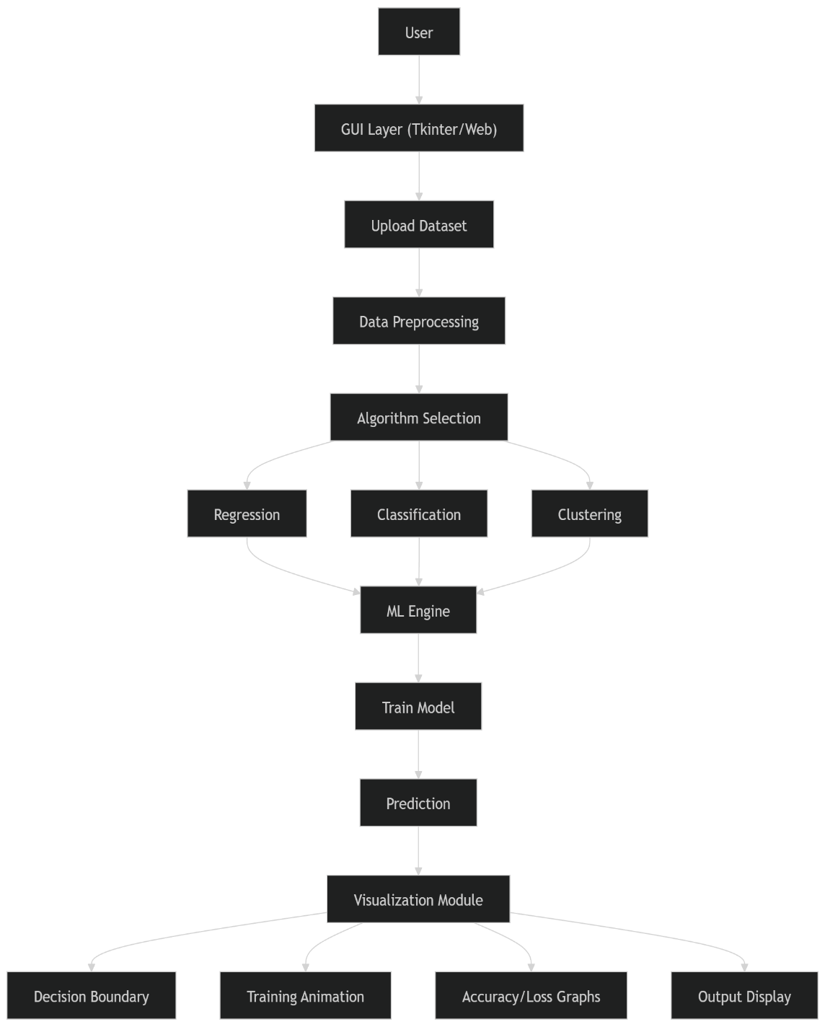
Fig-5.1: Architecture Diagram

CHAPTER-6

6.1 SYSTEM STUDY
The system study for Student Grades Prediction using Machine Learning with Flask involves analyzing the current environment, understanding user needs, and identifying the technical feasibility of developing an intelligent prediction system. It provides a clear understanding of how the system will operate and the resources required for its implementation.Educational institutions often face challenges in accurately evaluating and predicting student performance. Traditional methods rely on manual analysis and periodic assessments, which are time-consuming and may not provide early insights into student progress. There is a need for an automated system that can analyze historical data and predict student grades effectively.

6.1.1 FEASIBILITY STUDY

A preliminary feasibility study was conducted to evaluate the practicality and viability of the proposed visualization system. This ensures that the project can be successfully developed, implemented, and maintained within the given constraints of time, technology, and budget. The study is categorized into three major aspects:
1. Technical Feasibility: Technical feasibility determines whether the required technology, tools, and expertise are available to build the system.
- The system is developed using Python, which is widely supported and easy to use
- Machine learning libraries such as NumPy, Pandas, and Scikit-learn provide efficient tools for data processing and model building
- Flask enables smooth integration of machine learning models into a web application
The hardware requirements (basic computer with moderate RAM) are minimal.
- Developers with basic knowledge of Python and web development can implement the system

2. Economic Feasibility:
The Economic feasibility analyzes the cost involved in developing and maintaining the system.
- Uses open-source technologies (Python, Flask, Scikit-learn) → No licensing cost
- Minimal hardware requirements → No need for expensive infrastructure
- Development cost is low compared to commercial software solutions
- Maintenance cost is also minimal

3. Operational Feasibility: Operational feasibility checks whether the system can be easily used and accepted by users.
- Simple web interface for easy interaction
- No need for advanced technical skills for end users
- Teachers and administrators can easily input data and get predictions
Improves efficiency in decision-making and student monitoring.

CHAPTER-7

7.1 SYSTEM DESIGN
7.1.1 The system design for Student Grades Prediction using Machine Learning with Flask defines the overall structure, components, and interactions within the system. It provides a blueprint for implementing the application efficiently and ensures that all modules work together to deliver accurate predictions.
The system design for Student Grades Prediction using Machine Learning with Flask is based on a modular client-server architecture that ensures efficient interaction between different components of the system. The design integrates a user-friendly frontend interface, a backend server, and a machine learning model to provide accurate and real-time predictions of student grades. The frontend is developed using HTML and CSS, allowing users such as students, teachers, or administrators to enter relevant details like attendance, study hours, and previous academic performance through a simple web form. This input data is then sent to the Flask backend server, which acts as the central controller of the system.
The backend processes user requests and performs necessary data preprocessing tasks, including data cleaning, handling missing values, encoding categorical variables, and scaling numerical features. Once the data is prepared, it is passed to the machine learning module, where a trained model—such as Linear Regression, Decision Tree, or Random Forest—analyzes the input and predicts the student’s grade. The trained model is stored using serialization techniques, enabling it to be reused without retraining each time the system runs. Optionally, a database can be included to store student records and historical data for further analysis and model improvement.

7.1.2 Class Diagram
The class diagram is used to refine the use case diagram and define a detailed design of the system. The class from this, each class may have certain A Class Diagram represents the static structure of the system by showing classes, their attributes, methods, and relationships. In this system, it defines how components like user input, data processing, and prediction models.
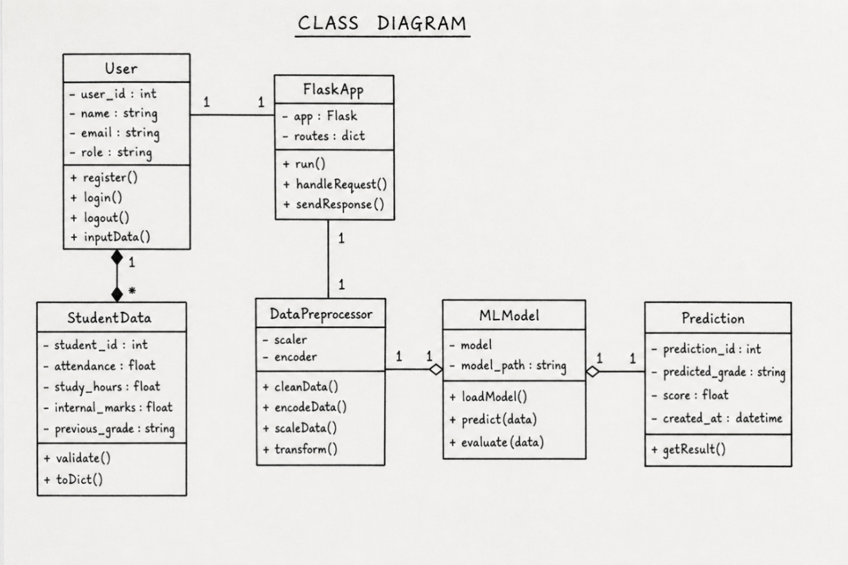
7.1.3 Sequence Diagram A sequence diagram in Unified Modeling Language (UML) is a kind of interaction diagram that shows how processes operate with one another and in what order. It is a construct of a Message Sequence Chart. A sequence diagram shows, as parallel vertical lines (“lifelines”), different processes or objects that live simultaneously, and as horizontal arrows, the messages exchanged between them, in the order in which they occur. This allows the specification of simple runtime scenarios in a graphical manner. For our visualization tool, it traces the sequence of operations from the user selecting a dataset, passing data to the ML engine, and the final realtions.

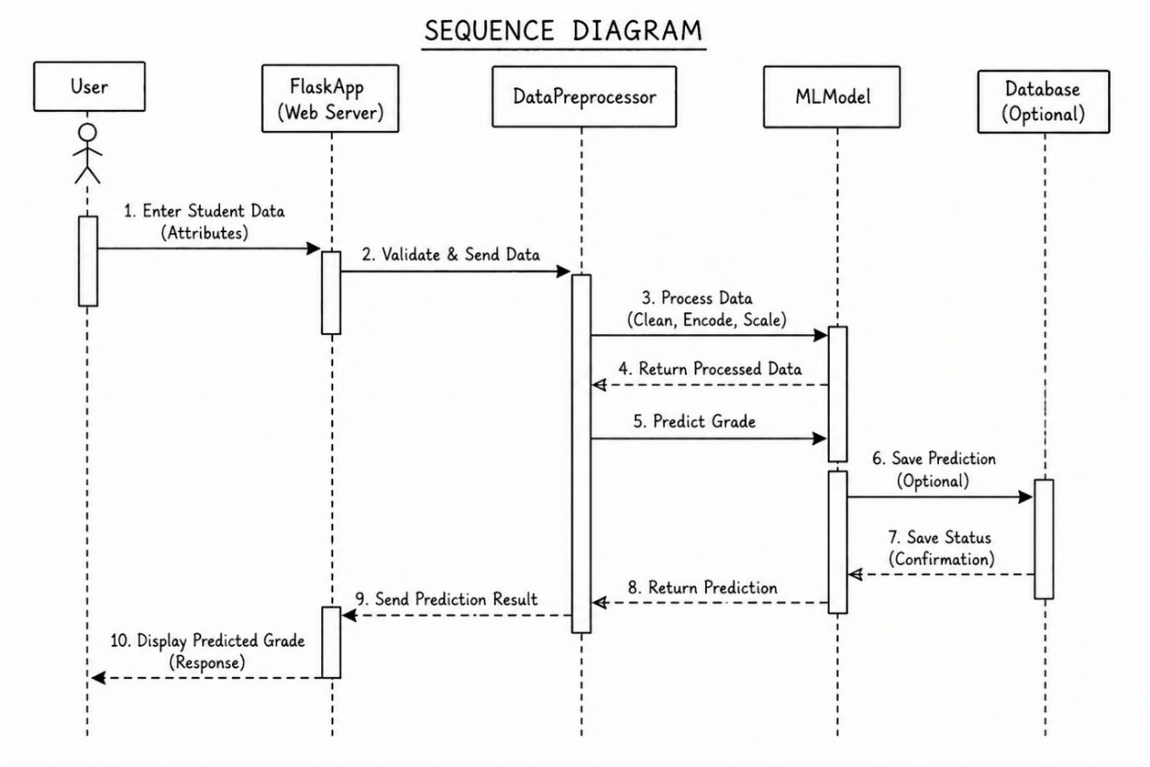
7.1.4 Activity Diagram Activity diagrams are graphical representations of workflows of stepwise activities and actions with support for choice, iteration, and concurrency. In the Unified Modeling Language, activity diagrams can be used to describe the business and operational step-by-step workflows of components in a system. An activity diagram shows the overall flow of control. Here, it maps out the user workflow, such as uploading data, configuring hyperparameters, training the model, and viewing the comparative performance graphs.
7.1.5 Data Flow Diagram A data flow diagram (DFD) is a graphical representation of how data moves within an information system. It is a modeling technique used in system analysis and design to illustrate the flow of data between various processes, data stores, data sources, and data destinations within a system or between systems. Data flow diagrams are often used to depict the structure and behavior of a system, emphasizing the flow of data and the transformations it undergoes. In this system, the DFD tracks how raw dataset values flow into the preprocessing unit, are consumed by the respective ML algorithms, and are outputted as graphical coordinate data for plotting.

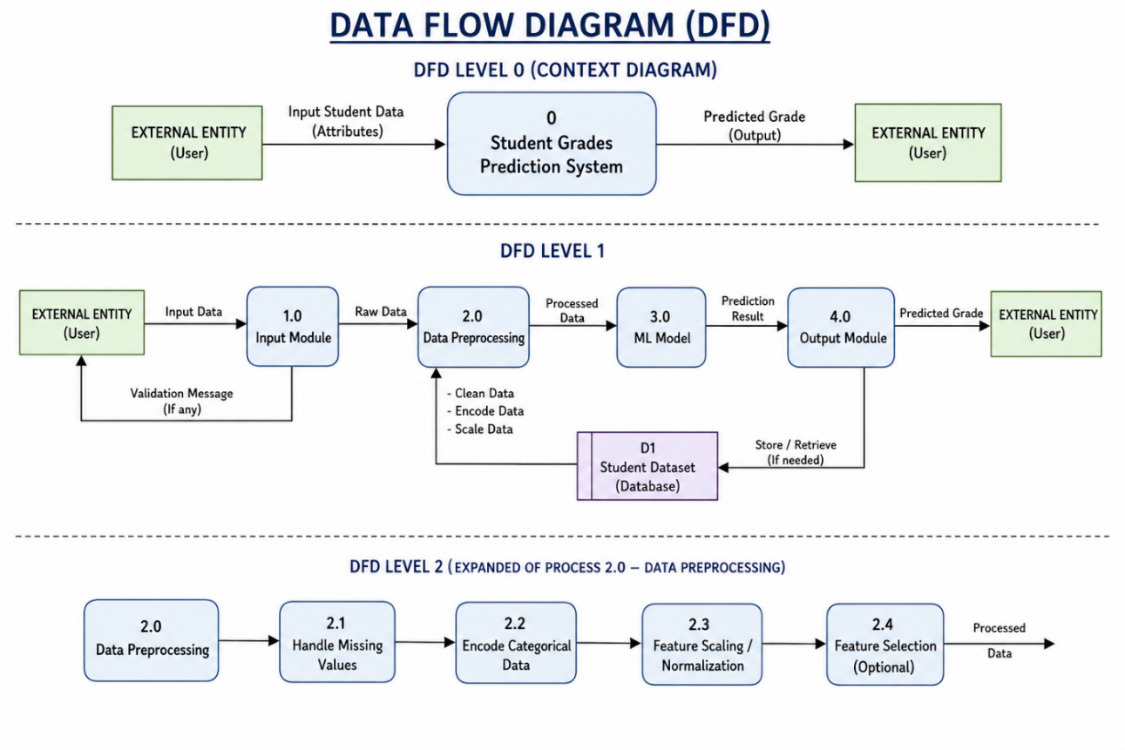
7.1.6 Component Diagram A component diagram describes the organization and wiring of the physical components in a system. This represents the wiring between the Tkinter UI components, the Scikit-learn/TensorFlow ML backend, and the Matplotlib plotting engine.
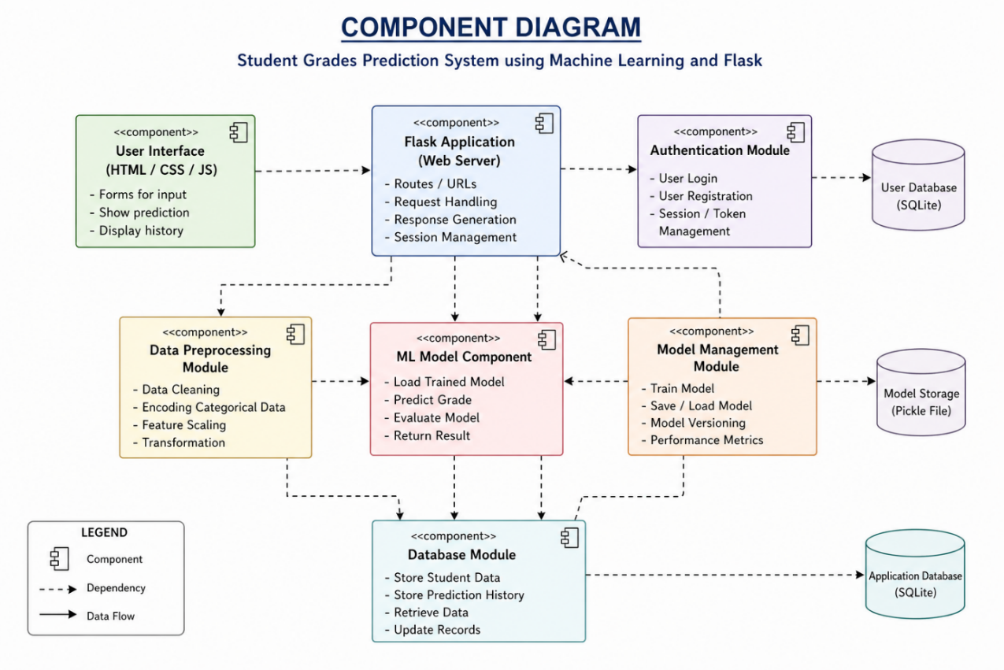
7.1.7 Use Case Diagram A use case diagram in the Unified Modeling Language (UML) is a type of behavioral diagram defined by and created from a Use-case analysis. Its purpose is to present a graphical overview of the functionality provided by a system in terms of actors, their goals (represented as use cases), and any dependencies between those use cases. The main purpose of a use case diagram is to show what system functions are performed for which actor. It identifies the primary actor (the User/Student) and their main goals: 'Upload Data', 'Train Model', 'Adjust Parameters',and 'Compare Algorithms'.
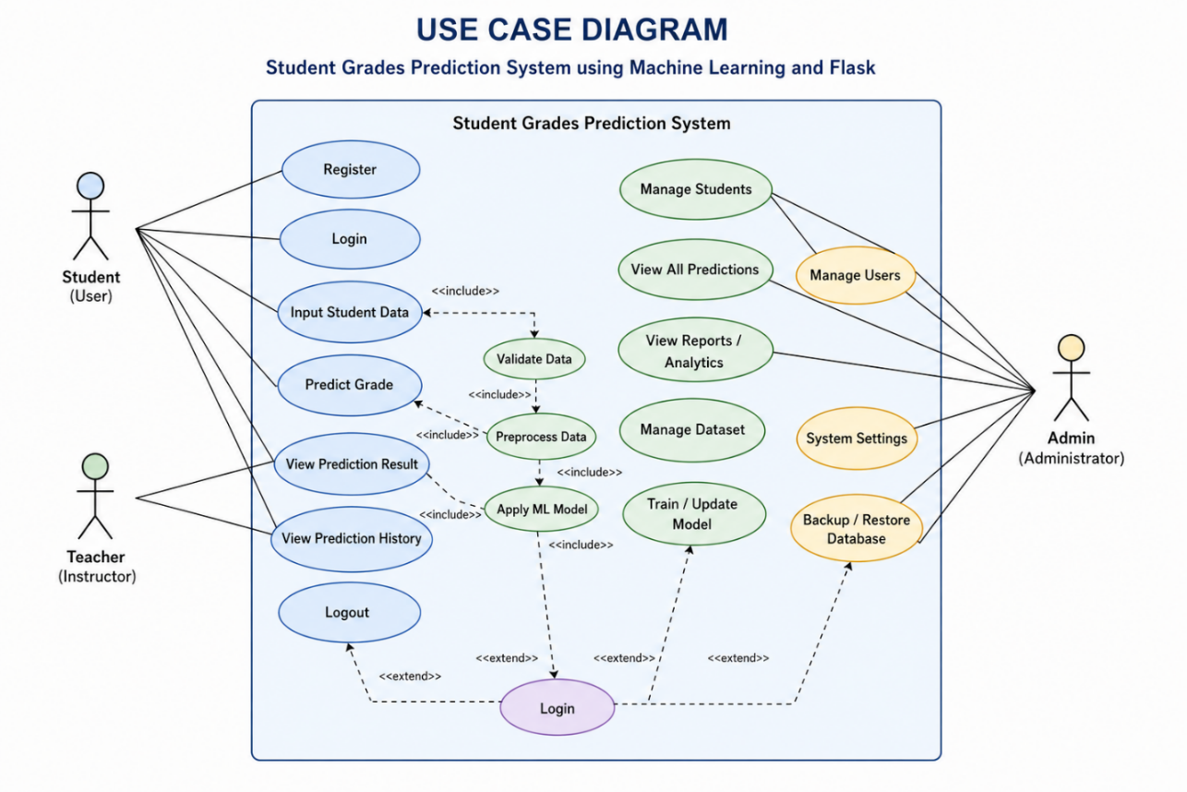7.1.8 Deployment Diagram A deployment diagram in UML illustrates the physical arrangement of hardware and software components in the system. It visualizes how different software artifacts, such as data processing scripts and model training components, are deployed across hardware nodes and interact with each other. It maps out the local machine execution environment, showing how the Python runtime hosts the GUI and communicates with underlying analytical libraries.

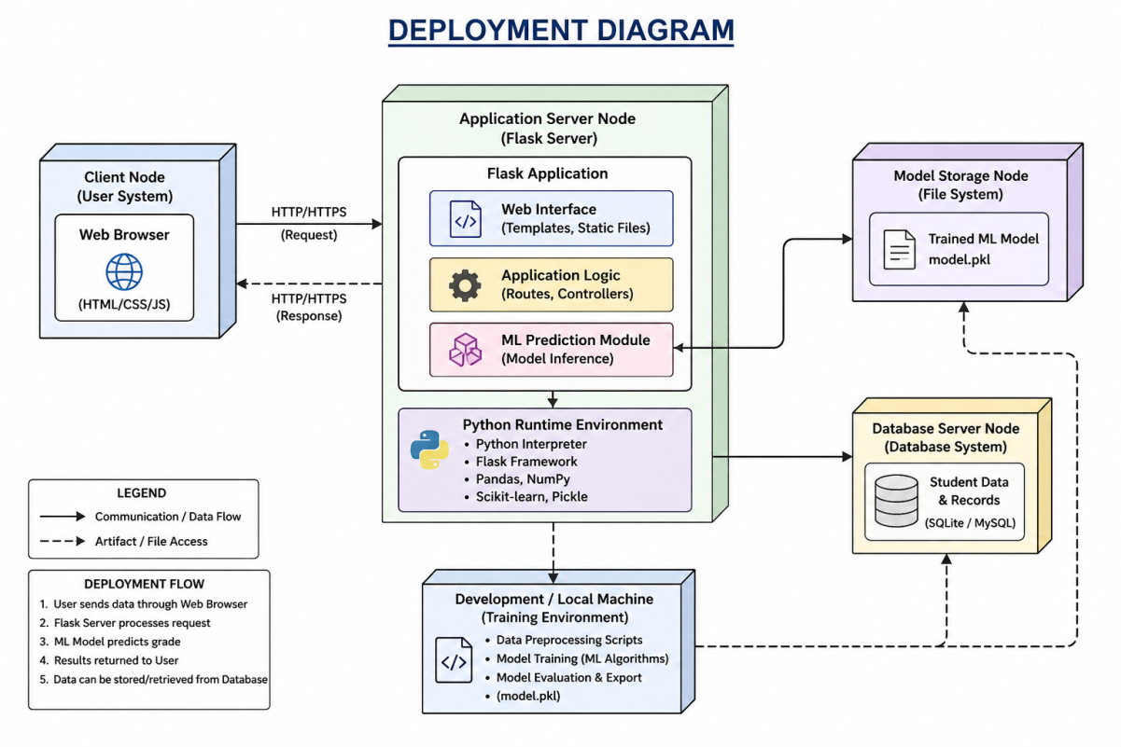

7.1.9 Architectural Block Diagram
An architectural block diagram provides a high-level abstraction of the system, illustrating the primary components and their interactions in a structured manner. It serves as a blueprint for understanding how different modules collaborate to achieve the system’s functionality and overall objectives. This diagram emphasizes modular design, ensuring scalability, maintainability, and efficient data flow within the application.
In the context of the Student Grades Prediction System, the architecture is divided into several key functional blocks:

1. User Interface (UI)
The User Interface acts as the front-end layer of the system, enabling interaction between users and the application. It is developed using web technologies integrated with the Flask framework. Users can input student-related data such as attendance, study hours, and previous academic records through structured forms. The UI ensures ease of use, responsiveness, and accessibility, providing a seamless experience for both students and educators.

2. Data Pipeline
The Data Pipeline is responsible for handling all data-related operations, including data collection, preprocessing, and transformation. Raw input data is cleaned, normalized, and converted into a suitable format for machine learning models. This stage includes handling missing values, encoding categorical variables, and feature scaling. A well-structured pipeline ensures data consistency and improves model accuracy.

3. Machine Learning Computational Core
This is the central component of the system where predictive analysis takes place. It includes multiple machine learning algorithms such as Support Vector Machines (SVM), Decision Trees, Random Forests, and Convolutional Neural Networks (CNN) (if applicable). The trained model processes input data and generates predictions based on learned patterns. This module is designed for efficiency, accuracy, and adaptability, allowing integration of different algorithms for performance comparison and optimization.

4. Model Management and Storage
This block handles the storage and retrieval of trained machine learning models. Models are saved in serialized formats (e.g., .pkl files) and loaded during runtime for prediction. It ensures version control, reproducibility, and efficient deployment of models without retraining.

5. Backend Processing (Flask Server)
The Flask backend acts as the bridge between the user interface and the machine learning model. It processes incoming requests, invokes the prediction logic, and returns results to the user. It also manages routing, API handling, and integration with data processing modules.

6. Visual Analytics Dashboard
The Visual Analytics Dashboard presents prediction results and insights in an intuitive and graphical format. It may include charts, performance metrics, and comparative analysis of student data. This helps educators make informed decisions and identify trends in student performance.
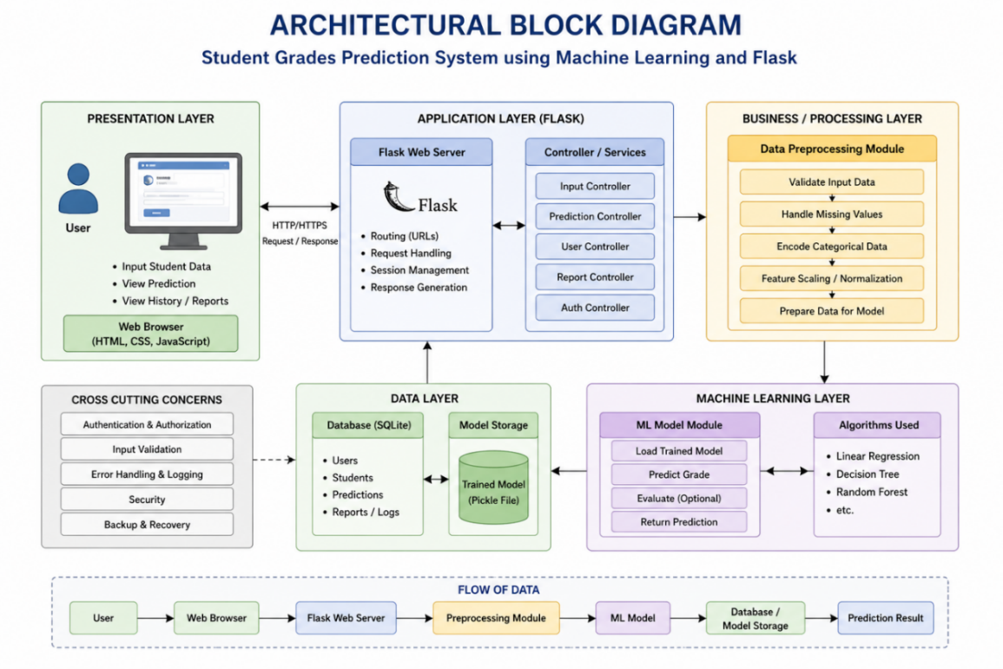
7.2 SOFTWARE ENVIRONMENT
What is Python: Below are some facts about Python:
- Python is currently the most widely used multi-purpose, high-level programming language.
- Python allows programming in Object-Oriented and Procedural paradigms. Python programs generally are smaller than other programming languages like Java.
- Programmers have to type relatively less, and the indentation requirement of the language makes it readable all the time.
- Python language is being used by almost all tech-giant companies like – Google, Amazon, Facebook, Instagram, Dropbox, Uber, etc.
- The biggest strength of Python is its huge collection of standard libraries which can be used for the following:
  - Machine Learning
  - GUI Applications (like Kivy, Tkinter, PyQt, etc.)
  - Web frameworks like Django (used by YouTube, Instagram, Dropbox)
  - Image processing (like OpenCV, Pillow)
  - Web scraping (like Scrapy, Beautiful Soup, Selenium)
  - Test frameworks
  - Multimedia
Advantages of Python: Let’s see how Python dominates over other languages.
- Extensive Libraries: Python downloads with an extensive library, containing code for various purposes like regular expressions, unit-testing, web browsers, threading, databases, image manipulation, and more. We don’t have to write the complete code manually.
- Extensible: Python can be extended to other languages. You can write some of your code in languages like C++ or C. This comes in handy, especially in large projects.
- Embeddable: Complimentary to extensibility, Python is embeddable as well. You can put your Python code in your source code of a different language, like C++.
- Improved Productivity: The language’s simplicity and extensive libraries render programmers more productive than languages like Java and C++ do.
- IoT Opportunities: Since Python forms the basis of new platforms like Raspberry Pi, it has a bright future for the Internet of Things, connecting the language with the real world.
- Simple and Easy: When working with Java, you may have to create a class just to print ‘Hello World’. In Python, just a print statement will do. It is quite easy to learn, understand, and code.
- Readable: Because it is not a verbose language, reading Python is much like reading English. It does not need curly braces to define blocks, and indentation is mandatory, further aiding the readability of the code.
- Object-Oriented: This language supports both the procedural and object-oriented programming paradigms. Classes and objects let us model the real world.
- Free and Open-Source: Python is freely available. Not only can you download Python for free, but you can also download its source code, make changes to it, and distribute it.
- Portable: Python follows the "Write Once Run Anywhere" (WORA) principle. You need to code only once, and you can run it anywhere, provided you avoid system-dependent features.
- Interpreted: Statements are executed one by one, making debugging easier than in compiled languages.

Advantages of Python Over Other Languages:
- Less Coding: Almost all tasks done in Python require less coding compared to other languages. Python has awesome standard library support, eliminating the need to search for third-party libraries for basic tasks.
- Affordable: Python is free; therefore, individuals and big organizations can leverage available resources to build applications. The 2019 GitHub annual survey showed that Python had overtaken Java in the most popular programming language category.
- Python is for Everyone: Python code can run on any machine. Programmers can professionally build web apps, perform data analysis and machine learning, automate tasks, and build powerful visualizations. It is an all-rounder programming language.
Disadvantages of Python:
- Speed Limitations: Because Python is interpreted line by line, it often results in slower execution compared to compiled languages. This is only a problem if extreme execution speed is a strict requirement.
- Weak in Mobile Computing and Browsers: While it serves as an excellent server-side language, Python is rarely seen on the client-side or used to implement smartphone-based applications due to security and optimization constraints.
- Design Restrictions: Python is dynamically-typed (using duck-typing). While this is easy on programmers during coding, it can raise unexpected run-time errors.
- Underdeveloped Database Access Layers: Compared to technologies like JDBC and ODBC, Python’s database access layers are a bit underdeveloped, making it less often applied in legacy enterprise database routing.
- Simplicity: Python’s extreme simplicity can be a hurdle for developers transitioning to more verbose and strictly-typed languages later on developed.

7.3 History of Python
What do the alphabet and the programming language Python have in common? Right, both start with ABC. If we are talking about ABC in the Python context, it's clear that the programming language ABC is meant. ABC is a general-purpose programming language and programming environment, which had been developed in the Netherlands, Amsterdam, at the CWI (Centrum Wiskunde& Informatica). The greatest achievement of ABC was to influence the design of Python.
Python was conceptualized in the late 1980s. Guido van Rossum worked at that time on a project at the CWI called Amoeba, a distributed operating system. In an interview, Guido van Rossum said: "In the early 1980s, I worked as an implementer on a team building a language called ABC at Centrum voorWiskundeen Informatica (CWI). I don't know how well people know ABC's influence on Python. I try to mention ABC's influence because I'm indebted to everything I learned during that project and to the people who worked on it."
Later in the same interview, he continued: "I remembered all my experience and some of my frustration with ABC. I decided to try to design a simple scripting language that possessed some of ABC's better properties, but without its problems. So, I started typing. I created a simple virtual machine, a simple parser, and a simple runtime. I made my own version of the various ABC parts that I liked. I created a basic syntax, used indentation for statement grouping instead of curly braces or begin-end blocks, and developed a small number of powerful data types: a hash table (or dictionary, as we call it), a list, strings, and number.
CHAPTER-8

8.1 IMPLEMENTATION AND METHODOLOGY

The implementation and methodology for the Student Grades Prediction system using machine learning with the Flask framework describe the structured process followed to design, develop, and deploy the application. This approach integrates data analysis, machine learning techniques, and web development to provide accurate and real-time predictions of student performance.

8.2 MODULE DESCRIPTION

The system is implemented across four primary modules:

1. Graphical User Interface (GUI) Module:

The User Interface Module provides interaction between the user and the system. It is developed using HTML, CSS, and optionally JavaScript to create a simple and user-friendly web interface. This module allows users such as students, teachers, or administrators to input student-related data like attendance, study hours, and previous grades. It also displays the predicted results clearly. The main goal of this module is to ensure ease of use and accessibility without requiring technical expertise..

2. Data Ingestion and Preprocessing Module:

The Data Preprocessing Module is responsible for preparing the input data before it is passed to the machine learning model. It performs essential tasks such as data cleaning, handling missing values, encoding categorical variables, and scaling numerical data. This module ensures that the input data is consistent, accurate, and in the correct format required by the model. Proper preprocessing plays a critical role in improving the accuracy and performance of the prediction system.

3. Machine Learning Computational Engine:
This is the core analytical module, implemented The Machine Learning Module is the core component of the system. It involves selecting, training, and applying machine learning algorithms such as Linear Regression, Decision Tree, and Random Forest. This module analyzes the processed data and learns patterns from historical student records. Once trained, the model is used to predict student grades based on new input data. The trained model is stored using serialization techniques so that it can be reused without retraining each time.

4. Flask Backend Module:

I The Flask Backend Module acts as the bridge between the user interface and the machine learning model. Built using the Flask framework, it handles HTTP requests and responses, manages application routing, and integrates all system components. When a user submits data through the interface, this module receives the input, sends it to the preprocessing and machine learning modules, and returns the predicted result to the frontend.

8.3 ALGORITHMIC IMPLEMENTATION DETAILS

The algorithmic implementation of the Student Grades Prediction using Machine Learning system with the Flask framework focuses on how data is processed and how predictions are generated using machine learning algorithms

Input Data Handling:

The system begins by accepting student-related data such as attendance, study hours, internal marks, and previous grades. This data is collected either from a dataset during training or from user input during prediction. The input data is structured into a feature vector representing each student.

Data Preprocessing Algorithm:

The preprocessing step ensures that the input data is clean and suitable for machine learning. The following operations are performed:

Remove or fill missing values

Convert categorical data into numerical format using encoding techniques

Normalize or scale numerical features

Split dataset into training and testing sets

Model Training Algorithm:

The trained model is evaluated using test data to measure its performance.

1. Input test dataset

2. Predict output using trained model

3. Compare predicted values with actual values.

4. Calculate performance metrics:

- Accuracy

- Mean Squared Error (MSE)

- R² Score

Prediction Algorithm:

Once the model is trained and deployed, it is used to predict student grades in real time.1. User enters input data via web form

2. Flask receives input

3. Preprocess input data

4. Load trained model

5. Pass input to model

6. Model predicts grade

7. Return result to user interface

8.4 SYSTEM EXECUTION FLOW

The step-by-step execution methodology follows this sequence:

User Accesses the system: The user opens the web application through a browser and navigates to the input page.

Input of Student Data:The user enters required details such as attendance, study hours, internal marks, and previous grades in the form provided.

Submission of Data:After entering the details, the user submits the form. The data is sent to the Flask backend through an HTTP request.

Request Handling by Flask Server:The Flask application receives the input data and initiates processing by routing the request to the appropriate function.

Input Validation:Extraction& Rendering: The system checks whether the entered data is valid, complete, and in the correct format. Any invalid inputs are handled with error messages.

Data Preprocessing:The validated data is cleaned and transformed. This includes encoding categorical values, scaling numerical features, and formatting data according to model requirements.

Loading the Trained Model
The system loads the pre-trained machine learning model from storage
(using Pickle/Joblib).

CHAPTER-9

9.1 SYSTEM TEST

System testing for the Student Grades Prediction using Machine Learning system implemented with Flask ensures that the entire application works correctly, efficiently, and reliably. It verifies that all modules—user interface, preprocessing, machine learning model, and backend—function together as expected.The main objective of system testing is to validate that the system meets functional and non-functional requirements. It ensures that predictions are accurate, the system handles inputs properly, and the application performs well under different conditions.

9.2 TYPES OF TESTS

Unit Testing

Unit testing involves the design of test cases that validate that the internal program logic is functioning properly, and that program inputs produce valid outputs. Individual components such as data preprocessing functions, model prediction functions, and Flask routes are tested separately to ensure correctness.

Integration Testing

Integration tests are designed to test integrated software components to determine if they actually run as one program. Testing is event-driven and is more concerned with the basic outcome of screens or fields. Integration tests demonstrate that although the components were individually satisfactory (e.g., the Tkinter UI works, and the Scikit-learn model trains), the combination of components is correct (e.g., sliding the 'Epoch' slider in the UI successfully updates the model's training loop in the backend). Integration testing is specifically aimed at exposing the problems that arise from the combination of the data pipeline, the ML engine, and the visualization renderer.

Functional Test

Functional tests provide systematic demonstrations that functions tested are available as Functional testing ensures that all features of the system work as intended:

Input form accepts valid student data

Invalid inputs are handled with proper error messages.

Data preprocessing works correctly

Machine learning model generates predictions

Results are displayed accurately on the web interface.

System Test

System testing ensures that the entire integrated software system meets requirements. It tests a configuration to ensure known and predictable results. An example of system testing for this project is running a complete end-to-end workflow: selecting the MNIST dataset, configuring a 3-layer CNN, hitting 'Train', and verifying that the final accuracy metrics and feature map visualizations are displayed concurrently without system freezing or memory leaks.

White Box Testing

White Box Testing is testing in which the software tester has knowledge of the inner workings, structure, and language of the software. It is used to test areas that cannot be reached from a black box level, such as verifying the specific array shapes being passed between the convolutional layers before they are rendered to the screen.

Black Box Testing

Black Box Testing is testing the software without any knowledge of the inner workings, structure, or language of the module being tested. The test provides inputs (e.g., clicking the 'Compare Models' button) and responds to outputs (e.g., checking if the bar chart appears) without considering how the Python backend processed the request.

Test Strategy and Approach Field testing will be performed manually, and functional tests will be written in detail.

Test Objectives:
The main objective of system testing is to validate that the system meets functional and non-functional requirements. It ensures that predictions are accurate, the system handles inputs properly, and the application performs well under different conditions.

Features to be Tested:
Test Case ID | Input | Expected Output | Result
TC01 | Valid student data | Correct grade prediction | Pass
TC02 | Missing input values | Error message displayed | Pass
TC03 | Invalid data format | Validation error | Pass
TC04 | High input values | System handles without crash | Pass
TC05 | Multiple requests | Fast response | Pass

CHAPTER-10

RESULTS AND DISCUSSION:

10.1 FINAL OUTPUT AND SCREENSHOTS

The final output of theStudent Grades Prediction using Machine Learning system developed with the Flask framework is the predicted academic performance of a student based on the input parameters provided by the user. The system generates this output in real time through a web-based interface.
Figure 10.1: Main Dashboard Interface: Displays the Tkinter GUI where users can upload datasets.
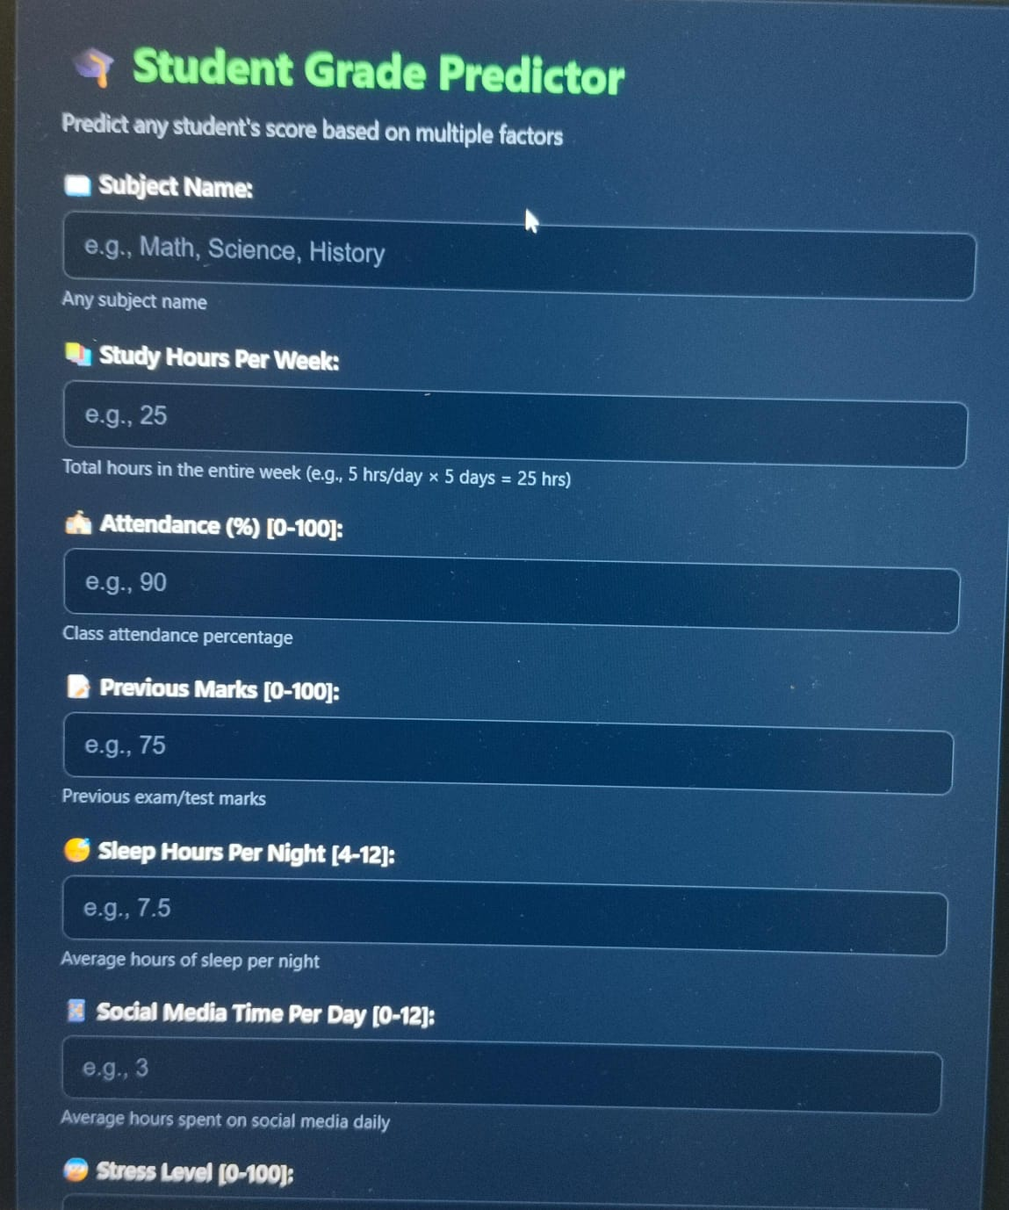

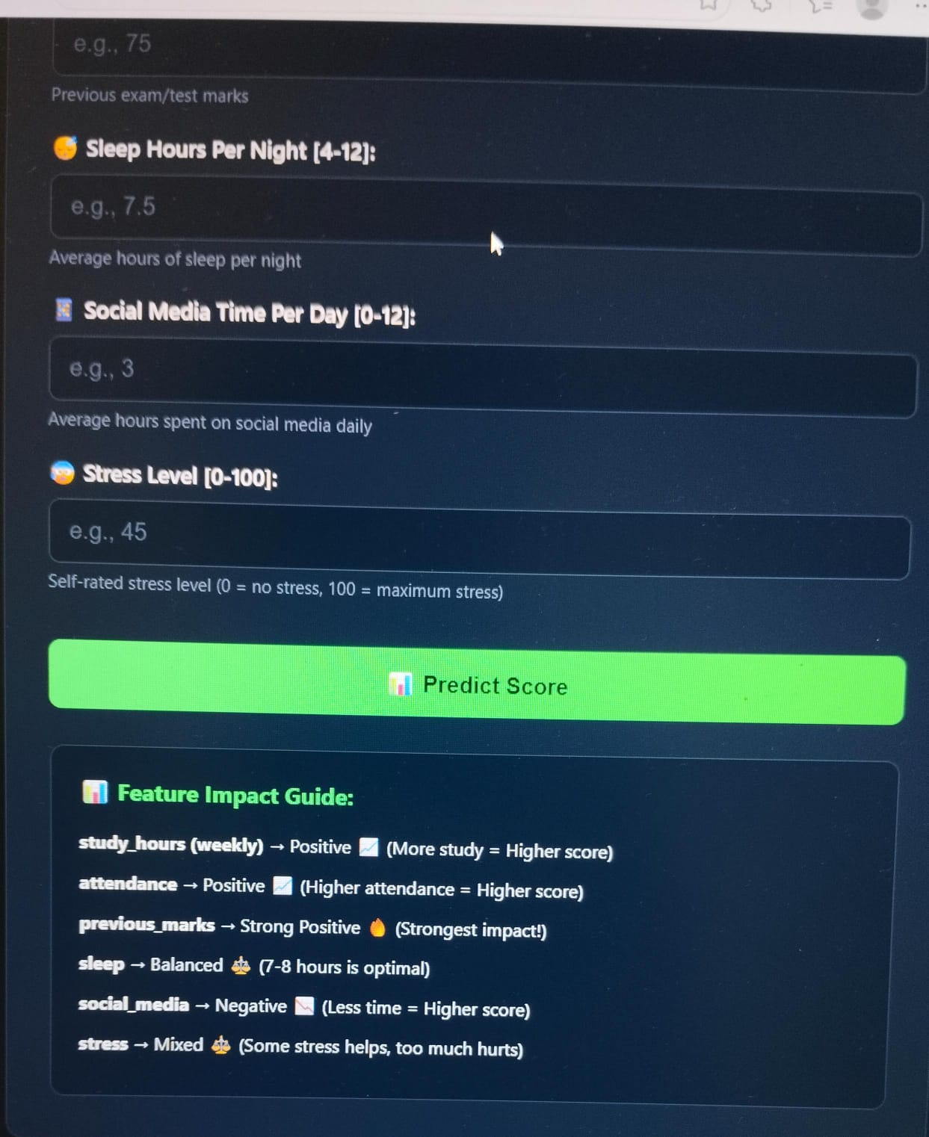

Figure 10.2: ENTER DATA :The system was able to process input data such as attendance, study hours, internal marks, and previous grades, and generate predictions in real time through the Flask web interface. The response time of the system was fast, and the user interface was simple and easy to use. This confirms that the integration of machine learning with web technologies is effective for practical applications.

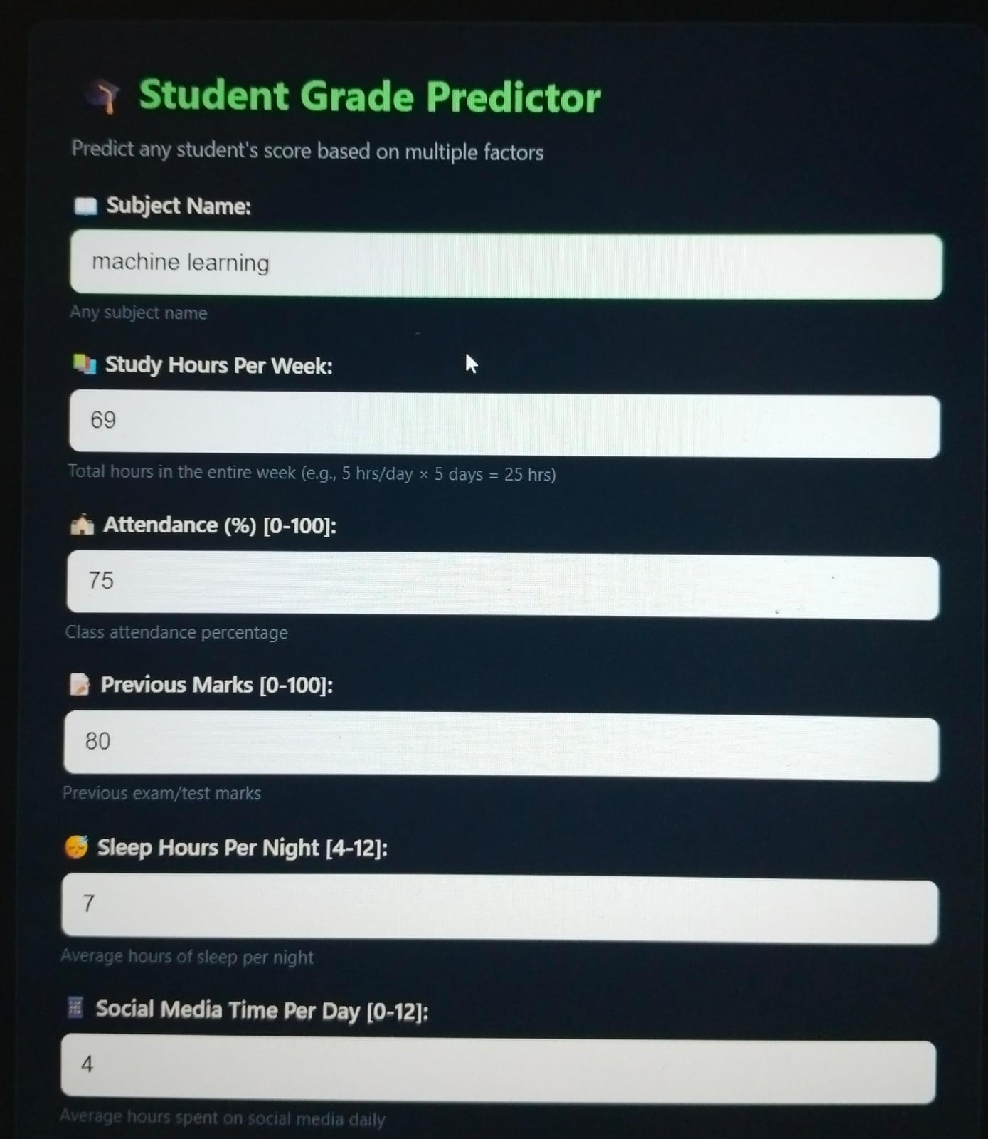

Figure 10.3: DISPLAY FINAL PREDICTION: Displays the The combination of machine learning techniques with the Flask framework provides a scalable and user-friendly solution for predicting student grades and improving academic performance.

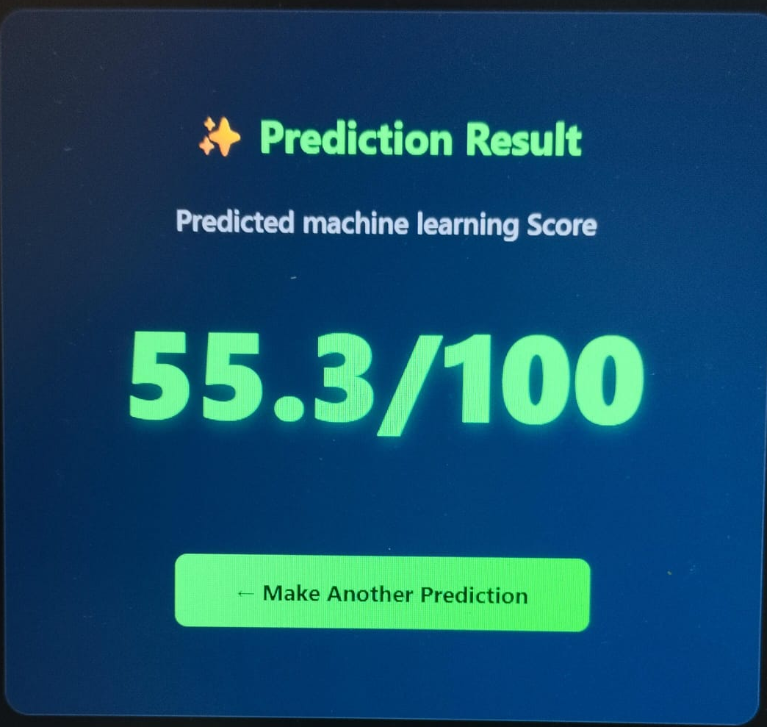
10.2 PERFORMANCE METRICS & COMPARATIVE ANALYSIS
The performance of the Student Grades Prediction using Machine Learning system implemented with the Flask framework is evaluated using standard machine learning metrics. These metrics help determine the accuracy, reliability, and efficiency of the prediction models used in the system.
Accuracy measures the percentage of correct predictions made by the model. It is commonly used for classification problems where grades are categorized (A, B, C, etc.).MSE calculates the average squared difference between actual and predicted values. Lower MSE indicates better model performance.

10.3 COMPARATIVE ANALYSIS OF ALGORITHMS
Different machine learning algorithms were implemented and compared to determine the best-performing model.

Algorithm | Accuracy | MSE/RMSE | R² Score | Remarks
Linear Regression | Moderate | Moderate | Moderate | Simple and fast but less accurate for complex data
Decision Tree | Good | Low | Good | Handles non-linear data but may overfit
Random Forest | High | Very Low | High | Best performance, reduces overfitting
SupportVector Machine | Good | Low | Good | Effective but computationally expensive

10.4 DISCUSSION OF RESULTS

The results obtained from the Student Grades Prediction using Machine Learning system implemented with the Flask framework demonstrate that machine learning techniques can effectively predict student academic performance with a high level of accuracy and efficiency. The system was evaluated using multiple algorithms, including Linear Regression, Decision Tree, and Random Forest, and their performance was analyzed based on standard evaluation metrics.Overall, the results confirm that the proposed system is effective, scalable, and suitable for academic performance prediction.

10.5 LIMITATIONS OF THE CURRENT SYSTEM
- The Student Grades Prediction using Machine Learning system developed using the Flask framework provides effective predictions; however, it has certain limitations that need to be considered for improvement and future development.
- One of the primary limitations of the system is its strong dependence on the quality and quantity of the dataset. If the training data is incomplete, inconsistent, or biased, the predictions generated by the model may not be accurate. The system performs best only when it is trained on clean and well-structured data.
- Another limitation is the lack of generalization across different educational environments. The model is trained on a specific dataset, and its performance may vary when applied to students from different institutions, regions, or academic systems. This reduces the adaptability of the system.

CHAPTER – 11

11. CONCLUSION AND FUTURE SCOPE

11.1 CONCLUSION
The “Student Grades Prediction using Machine Learning” system developed using the Flask framework successfully demonstrates the practical application of data-driven technologies in the field of education. In today’s academic environment, where large volumes of student data are generated continuously, traditional evaluation methods are often insufficient to identify patterns and predict outcomes effectively. This project addresses that limitation by leveraging machine learning algorithms to provide meaningful insights into student performance.
The system incorporates multiple machine learning techniques such as Linear Regression, Decision Tree, and Random Forest algorithms to analyze various academic and behavioral parameters of students. These parameters may include attendance, study time, previous academic records, and other relevant factors that influence student performance. By training the model on historical data, the system is capable of identifying underlying patterns and relationships, enabling accurate prediction of student grades.
Among the algorithms used, the Random Forest model has shown superior performance in terms of accuracy, reliability, and robustness. As an ensemble learning method, Random Forest combines multiple decision trees to reduce overfitting and improve generalization. This makes it particularly effective for handling complex datasets with multiple influencing factors. The comparative analysis of different models highlights the importance of selecting appropriate algorithms for achieving optimal prediction results.
The integration of the machine learning model with the Flask web framework enhances the usability and accessibility of the system. Flask provides a lightweight and efficient platform for deploying the predictive model as a web application. Users can easily input student data through a simple interface and obtain real-time predictions without requiring technical expertise. This makes the system practical for use by educators, administrators, and even students.

Furthermore, the system promotes data-driven decision-making in educational institutions. By predicting student performance in advance, educators can identify students who are at risk of underperforming and take timely corrective actions. This proactive approach can significantly improve learning outcomes, reduce dropout rates, and enhance overall academic performance. The system also reduces manual effort in analyzing student data, saving time and increasing efficiency.
Another important aspect of this project is its scalability and adaptability. The modular architecture allows for easy integration of additional features and improvements. The system can be extended to support larger datasets and deployed across multiple institutions with minimal modifications. This makes it a viable solution for modern educational systems that aim to incorporate technology for better academic management.
In conclusion, the Student Grades Prediction system successfully demonstrates the effectiveness of combining machine learning with web technologies. It provides an intelligent, efficient, and user-friendly solution for predicting academic performance. The project highlights the potential of artificial intelligence in transforming traditional education systems into more proactive, data-driven environments that support both students and educators.

11.2 FUTURE SCOPE
Although the current system achieves satisfactory performance and demonstrates practical utility, there are several opportunities for further enhancement and expansion. Future improvements can significantly increase the system’s accuracy, functionality, and real-world applicability.
One of the most important directions for future development is the integration of advanced machine learning and deep learning techniques. While traditional algorithms such as Linear Regression and Decision Trees provide good baseline performance, more sophisticated models like Artificial Neural Networks (ANN), Deep Neural Networks (DNN), and Long Short-Term Memory (LSTM) networks can capture more complex patterns in data. These models are particularly useful when dealing with large and diverse datasets, and they have the potential to improve prediction accuracy significantly.

Another key area for enhancement is the use of larger and more diverse datasets. The current system may be limited by the size and scope of the dataset used for training. By incorporating data from multiple institutions, different educational boards, and varied demographic backgrounds, the model can achieve better generalization. This will ensure that the system performs effectively across different academic environments and is not biased toward a specific dataset.
The incorporation of Explainable Artificial Intelligence (XAI) techniques is also an important future improvement. One of the challenges with machine learning models, especially complex ones, is their lack of transparency. Users often do not understand how predictions are made. By integrating explainable AI methods such as feature importance analysis, SHAP (SHapley Additive exPlanations), or LIME (Local Interpretable Model-Agnostic Explanations), the system can provide clear insights into the factors influencing each prediction. This will enhance user trust and make the system more reliable for decision-making.
Visualization is another area that can be significantly improved. Currently, the system provides predictions in a basic format, but future versions can include interactive dashboards and graphical representations. These may include charts, performance trends, comparison graphs, and heat maps that make the results easier to interpret. A well-designed visualization dashboard can help educators quickly identify patterns and take appropriate actions.
The system can also be expanded into a comprehensive academic monitoring platform. In addition to predicting grades, it can include features such as continuous student performance tracking, attendance monitoring, and behavioral analysis. Personalized learning recommendations can be generated based on individual student performance, helping students focus on areas where they need improvement. This will transform the system from a simple prediction tool into a complete educational support system.
Integration with mobile applications is another valuable enhancement. A mobile-friendly version of the system or a dedicated mobile app can increase accessibility and usability. Students and teachers can access predictions, reports, and analytics anytime and anywhere. This will make the system more convenient and widely usable in real-world scenarios.
Additionally, real-time data integration can be implemented by connecting the system with institutional databases or learning management systems (LMS). This will allow automatic data updates and eliminate the need for manual input. As a result, predictions will be more accurate and up-to-date.
Finally, the system can be enhanced by incorporating feedback mechanisms. Users can provide feedback on prediction accuracy, which can be used to continuously improve the model. This creates a self-learning system that evolves over time and adapts to new data patterns.
In summary, the future scope of the Student Grades Prediction system is vast and promising. By integrating advanced technologies, improving data handling, and expanding functionalities, the system can evolve into a powerful educational tool. These enhancements will not only improve prediction accuracy but also contribute to a more efficient, transparent, and student-centric learning environment.

CHAPTER-12

12. REFERENCES / BIBLIOGRAPHY

1. R. K. Sahu et al. (2020)
Title: Student Performance Prediction Using Machine Learning Techniques
Description:
This paper focuses on predicting student academic performance using classification algorithms such as Decision Trees and Naïve Bayes. It highlights how machine learning can identify weak students early and improve educational outcomes

2. A. Kumar & P. K. Bansal (2019)
Title: Predicting Student Academic Performance Using Data Mining Techniques
Description:
This research applies data mining methods to analyze student behavior and academic records. It emphasizes the importance of feature selection and preprocessing in improving prediction accuracy.

3. International Journal of Computer Applications (IJCA)
Title: Various Papers on Student Performance Prediction
Description:
IJCA publishes multiple Indian research papers on machine learning applications in education. These studies provide practical implementations of algorithms like Random Forest and Decision Trees for academic prediction.

4. IEEE India Conference Papers (2018–2023)
Title: Educational Data Mining and Student Prediction Models
Description:
IEEE India conference papers include real-world applications of machine learning in education systems, focusing on predictive analytics and intelligent decision-making tools.

5. Dr. S. Vijayarani et al. (2015)
Title: Predicting Student Performance Using Classification Algorithms
Description:
This study compares multiple classification techniques and demonstrates how machine learning can be effectively used in educational systems to improve student success rates.

6. Anna University Research Publications
Title: Academic Performance Prediction Using Machine Learning
Description:
Research from Anna University explores predictive models in education, focusing on student data analysis and early identification of low-performing students.

7. IIT Kharagpur Research Work
Title: Learning Analytics and Student Prediction Systems
Description:
Studies from IIT institutions emphasize advanced analytics and machine learning approaches for improving educational performance and institutional decision-making.

